**Logic App Creation**

1. Go to Logic Apps In “Azure Services”.

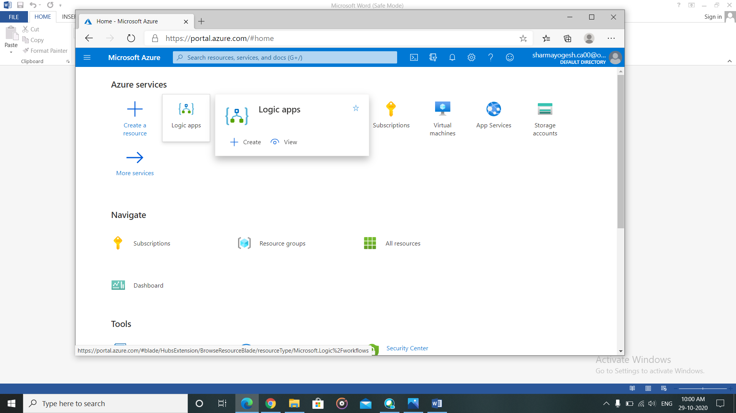

1. Click on “Add”.

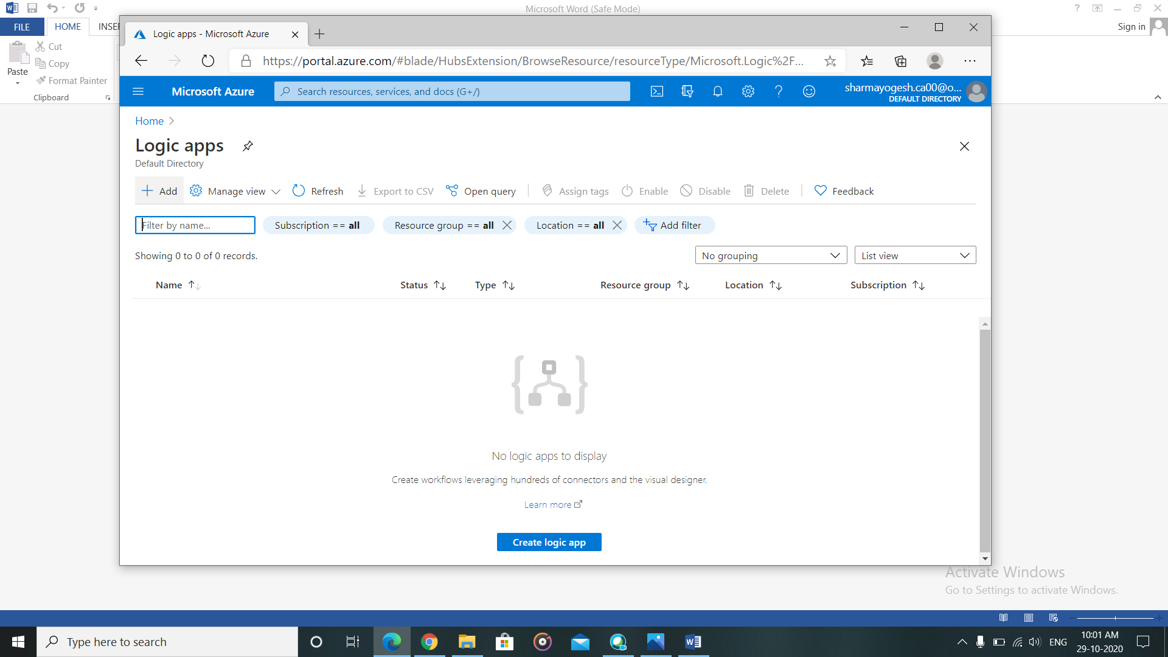

1. Fill the detail. Click “Review + Create” and then create.

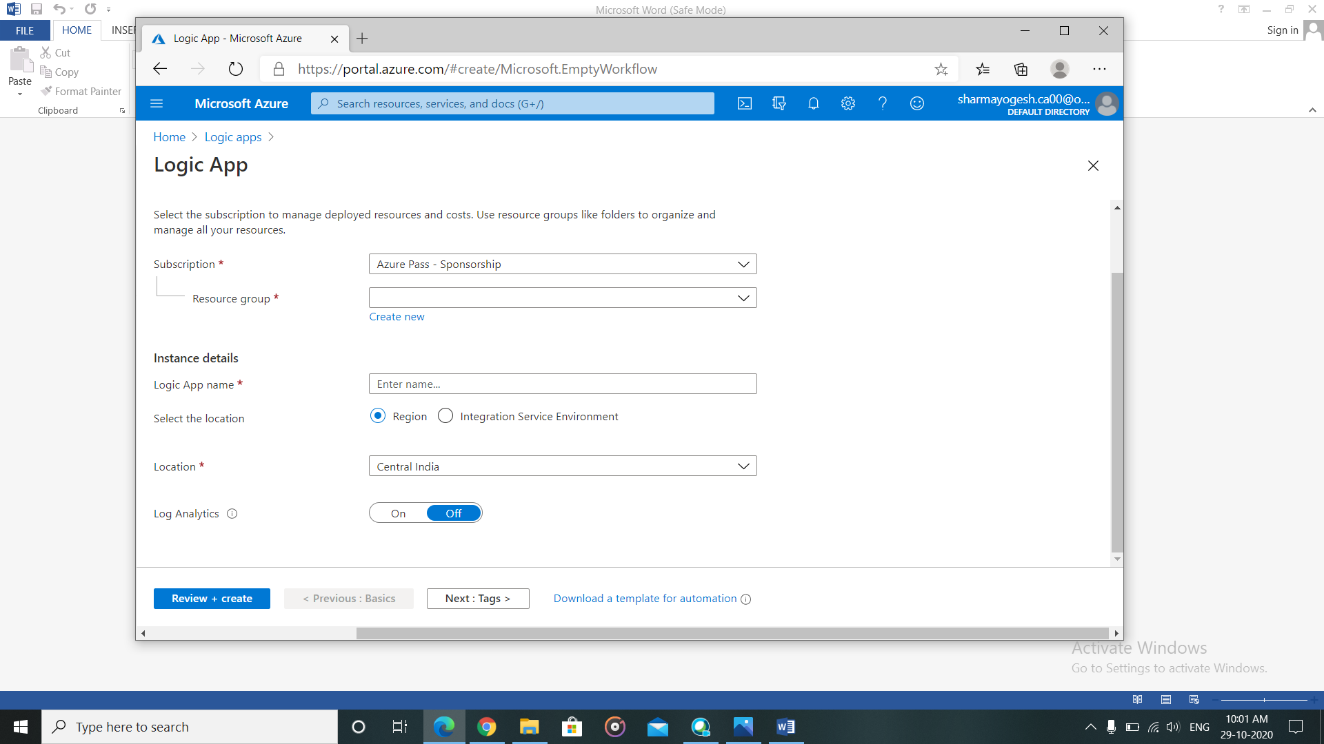

1. Wait for the deployment to get completed. Click on “Go to resource” after deployment is done.

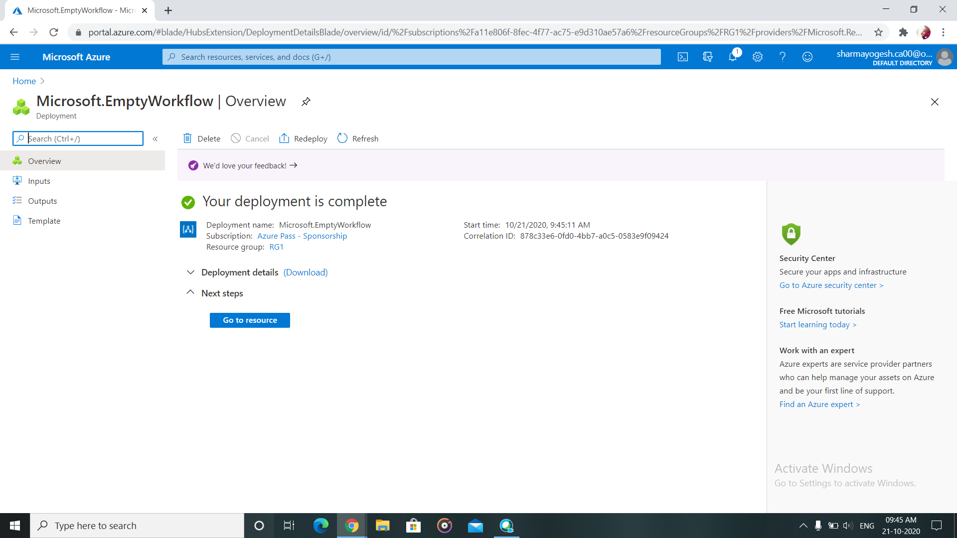

1. Choose from the triggers (here I choose “when a feed is published” and provide the RSS feed URL.

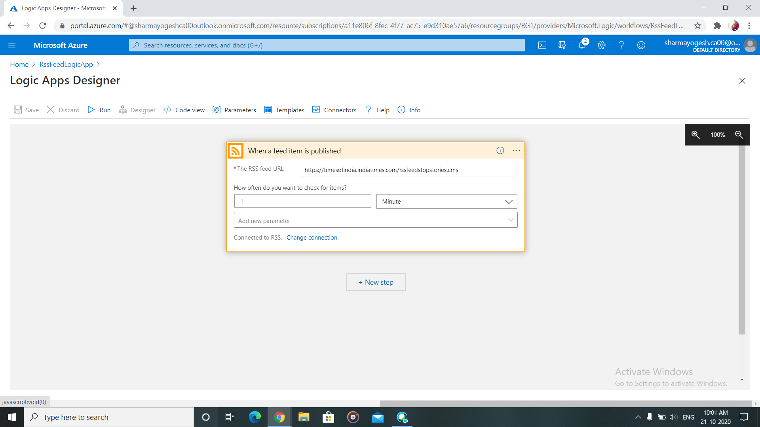

1. Click on “New Step” after filling all the details.

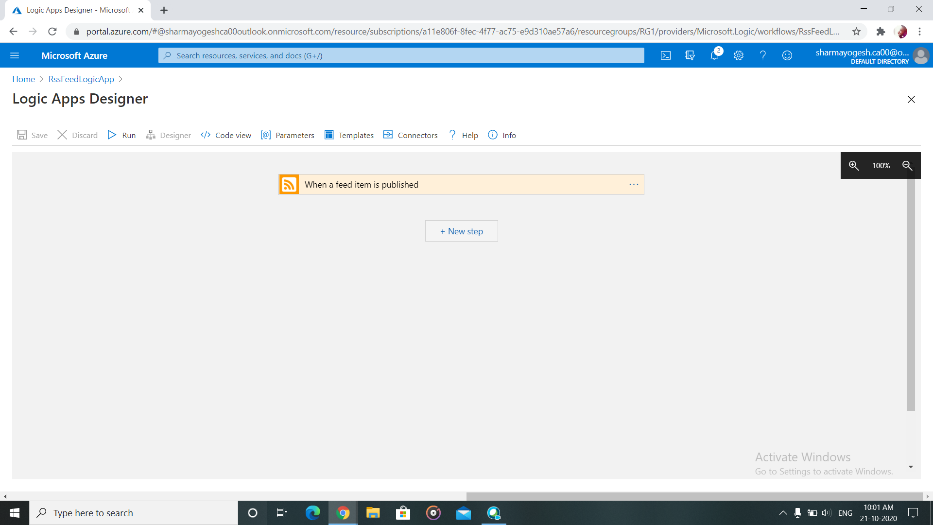

1. Search for the action/step you want to perform. (Gmail>send email).

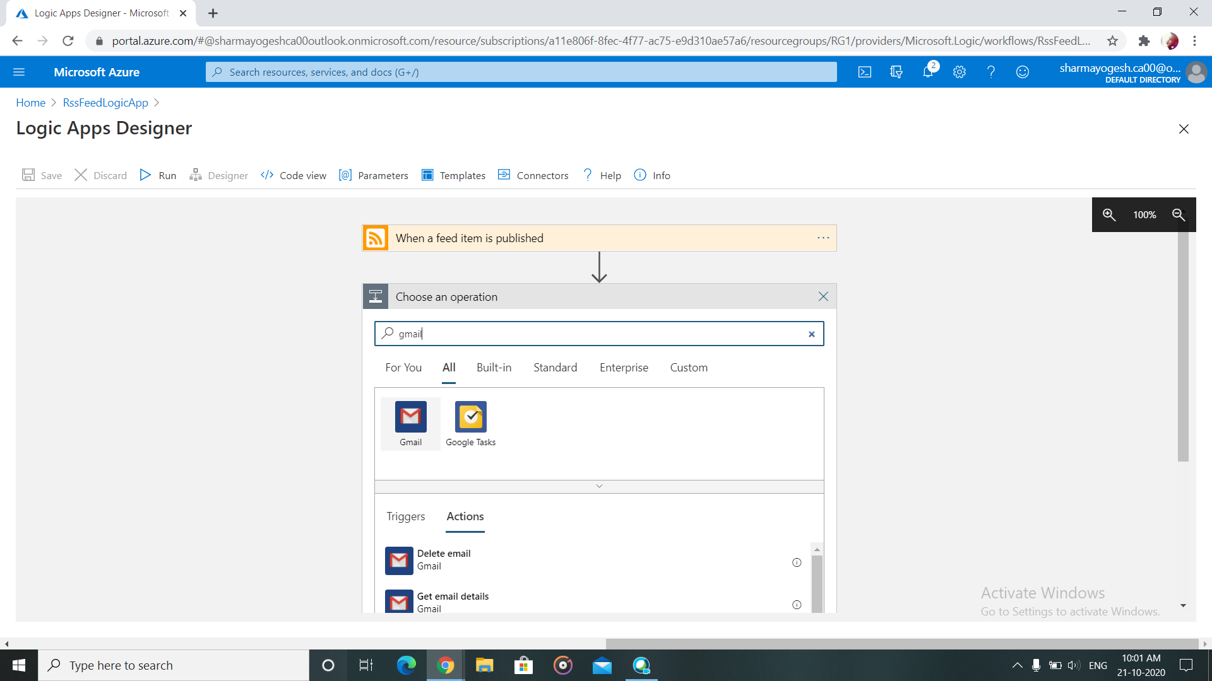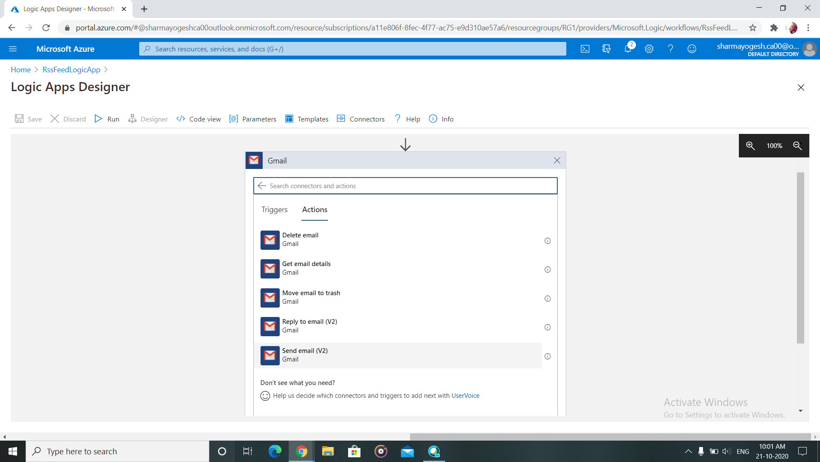

1. Provide the parameters and other details of how and whom to send the email. The mail will be sent after any new feed is published in TOI.